A Guide for Patients Beginning Buprenorphine Treatment at Home

Before you begin you want to feel very sick from your withdrawal symptoms
It should be at least . . . You should feel at least three of these symptoms . . .

- 12 hours since you used heroin/fentanyl • Restlessness • Body aches • Goose pimples
- 12 hours since snorted pain pills (Oxycontin) • Heavy yawning • Tremors/twitching • Stomach cramps, nausea,
- 16 hours since you swallowed pain pills • Enlarged pupils • Chills or sweating vomiting or diarrhea
- 48-72 hours since you used methadone • Runny nose • Anxious or irritable
Once you are ready, follow these instructions to start the medication
DAY 1:  8-12mg of buprenorphine  Most people feel better the first day after 8-12mg. (Dosing depends on how early on the first day you started) |  |  |  | DAY 2:  up to 16mg of buprenorphine
Step 1.  Take the Wait 45  first dose minutes  45  4mg minutes  - Put the tablet or strip under your tongue  - Keep it there until fully dissolved (about 15 min.)  - Do NOT eat or drink at this time  - Do NOT swallow the medicine | Step 2.  Still feel sick? Wait 6  Take next dose hours  6  4mg hours  Most people feel better after two doses = 8mg | Step 3.  Still Stop  uncomfortable?  Take last dose  4mg Stop  - Stop after this dose  - Do not exceed 12mg on Day 1 |  | Take up to a 16mg dose  Most people feel better with up to a 16mg dose  16mg  Repeat this dose until your next follow-up appointment
If you develop worsening symptoms while starting buprenorphine before your scheduled outpatient appointment return to the emergency department

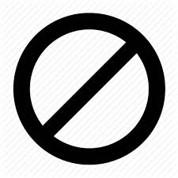
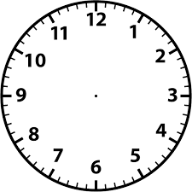
Note: This is a modified version of a NIDA guidance document

