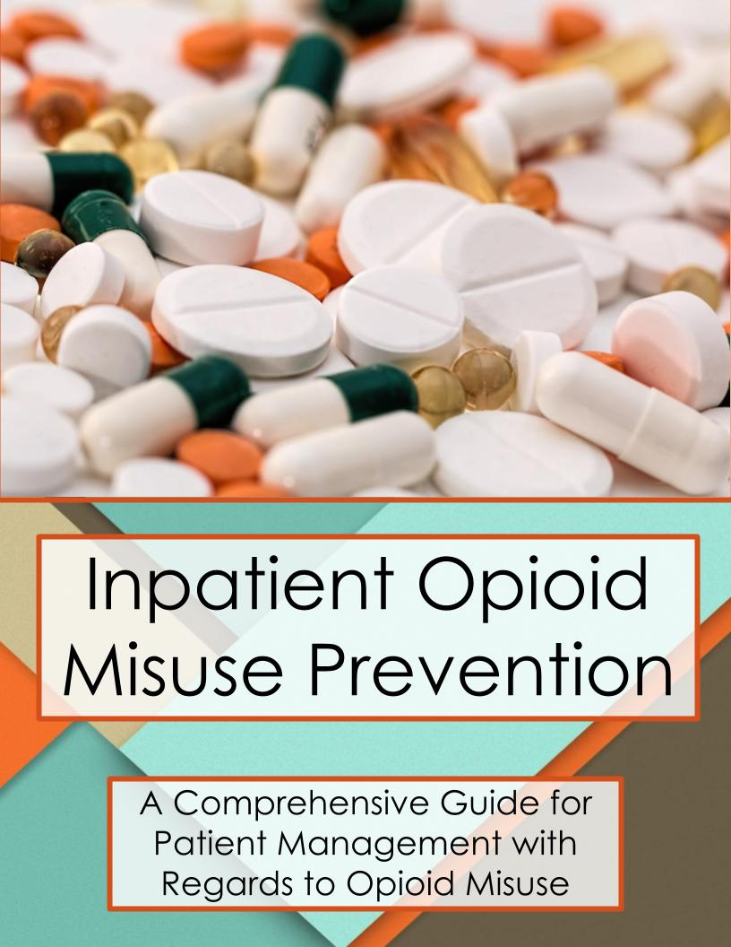

Inpatient Opioid Misuse Prevention
July 2018

Authors:
Ifeanyichukwu David Chinedozi
MD candidate, Tufts University School of Medicine, 2020

Deeb N. Salem, MD
Co-Interim CEO and Physician-in Chief, Tufts Medical Center; Sheldon M. Wolff Professor and Chairman, Department of Medicine, Tufts University School of Medicine

Megan V. Fernandez
MD candidate, University of Massachusetts Medical School, 2022

Steven M. Defossez, MD, EMHL, CPE
Vice President Clinical Integration, Massachusetts Health & Hospital Association

*For any questions on these guidelines please contact Steve Defossez, MD at sdefossez@mhalink.org or (781) 262-6006.

Contributing Institutions
- Baystate Medical Center, Springfield, MA
- Berkshire Medical Center, Pittsfield, MA
- Beth Israel Deaconess Medical Center, Boston, MA
- Brigham and Women’s Hospital, Boston, MA
- Boston Medical Center, Boston, MA
- Cambridge Health Alliance, Cambridge, MA
- HealthSouth Braintree Rehabilitation Hospital, Braintree, MA
- Lemuel Shattuck Hospital, Jamaica Plain, MA
- Maine Medical Center, Portland, ME
- Massachusetts General Hospital, Boston, MA
- Tucson Medical Center, Tucson, AZ
- Tufts Medical Center, Boston, MA
- Veterans Affairs Boston Healthcare System, Boston MA

Disclaimer: These clinical practice guidelines do not set a standard of care; rather they are an educational aid for providers. They do not set a single best course of management, nor do they include all available management options. They were developed by an interdisciplinary team based on published evidence and expert opinion. These guidelines should never be used as a substitute for clinical judgement. Individual providers are responsible for assessing the unique circumstances and needs of each case. Adherence to these guidelines will not ensure successful treatment in every situation. This information is intended for healthcare providers and subject matter experts; it is not intended for use by patients and the general population.

Table of Contents

Introduction  Opioid Misuse Prevention Recommendations  Issue 1 Screening for Opioid Use Disorder Among Patients Admitted for Inpatient Level of Care  Issue 2 Inpatient Acute Opioid Withdrawal  Issue 3 Responding to an Opioid Overdose  Issue 4 Management of Acute Pain in the Inpatient Setting for Patients with Chronic Opioid Use  Issue 5 Preventing Patients from Bringing Opioids into a Hospital  Issue 6 Visitors and Visitation  Issue 7 Educating Patients on the Risks of Opioid Misuse  Issue 8 Security De-Escalation for Staff and Patient Safety  Issue 9 Care for Patients Who Use Non-Prescribed Drugs While Receiving Care in the Hospital  APPENDIX A  Link to Patient and Family Agreement on Opioids  APPENDIX B  Decision Tree for Acute Withdrawal  APPENDIX C  Agitation Guidelines for Patients in Opioid Withdrawal  References | p. 3  p. 5  p. 5  p. 6  p. 9  p. 10  p. 14  p. 17  p. 18  p. 19  p. 20  p. 22  p. 22  p. 23  p. 24

Introduction
The CDC indicates that two million Americans suffer from an Opioid Use Disorder (OUD), a chronic medical condition. These patients are at elevated risk to leave against medical advice (AMA) and should their tolerance for opioids be reduced during hospitalization, they are at increased risk for overdose death following discharge. (McNeil 2014)

Using inpatient opioid agonist medications like methadone or buprenorphine to prevent patients from suffering withdrawal symptoms while hospitalized has many benefits, including compassionate symptom relief, reducing the rate of patients leaving against medical advice, enhancement of the doctor-patient relationship, enabling optimal treatment for the medical or surgical reason for admission, and increasing the likelihood the patient will choose recovery and long-term outpatient addiction treatment. (Donroe 2016)

Given the magnitude of the OUD problem, these guidelines were specifically developed to assist hospital-based practitioners to care for adults with OUD while they are inpatients, using compassion and evidence-based best practices.

Managing Opioid Misuse in an Inpatient Setting
Given the current prevalence of opioid misuse in Massachusetts, healthcare providers are seeing an increase in the incidence of patients and visitors bringing into hospitals unapproved items (for example, drug paraphernalia) as well as using illegal substances, such as heroin or non-prescribed opioids that result in an overdose or other related adverse effects while being treated in a hospital. This is true for patients admitted for addiction treatment as well as for patients admitted for unrelated medical or surgical treatment. Given the lack of standard recommendations for managing such misuse, the purpose of this guide is to provide a first-in-the-nation statewide comprehensive set of recommendations for clinicians and administrators to use in developing effective clinical policies to address opioid misuse in the hospital inpatient setting. While there are other clinical guidelines for treating opioid use disorders that have been developed in other states (such as the Support for Hospital Opioid Use Treatment (SHOUT)), these are the first issued by an association for statewide adoption. The recommendations in this document have the overarching goal to screen, treat, and manage a person with OUD, as well as to prevent the introduction and misuse of opioids within a hospital, either by a patient or a patient’s visitor. This document was developed through:
- Review of existing literature;
- Collaboration with hospitals within the Massachusetts Health and Hospital Association (MHA) membership;
- Incorporating policies hospitals within and outside of Massachusetts developed, regarding inpatient opioid addiction screening and treatment protocols, and involvement of caregivers and family members;
- Identifying best practices among the submitted protocols, backed up by literature review, and;
- Reviewing suggested clinical practices and operational policies that can be used within any hospital setting in Massachusetts or another state.

Problem
The American Society of Addiction Medicine defines addiction as a “primary, chronic disease of brain reward, motivation, memory and related circuitry.” (American Society of Addiction Medicine 2015) Disruptions in these important circuits lead to biological, psychological, social, and spiritual effects that challenge an individual’s ability to abstain from the substance or behavior. In the case of opioids, repeated exposure inhibits the body’s endogenous endorphin production, which contributes to the severe withdrawal symptoms typical for patients detoxifying from these drugs. (Volkow 2014)
Opioids are a class of drugs that act on opioid receptors found in brain neuronal cells, spinal cord, the gastrointestinal tract, and other organs throughout the body. When bound to these receptors, opioids diminish the perception of painful stimuli and produce euphoria by acting on the reward centers of the central nervous system. (Volkow 2014) Our current understanding reveals that addiction disorders impair not only neurotransmitters, but the reward centers of the central nervous system. (American Society of Addiction Medicine 2015) Although much work has been done in an attempt to better understand the neurobiology of the human reward center, the neurobiology of addiction as a disease is still under active investigation.
Rated as Schedule I and II drugs by the Food and Drug Administration, heroin and opioids, respectively, pose a risk for misuse and subsequent dependence. Multiple adverse effects have been linked to this problem, including non-fatal and fatal overdoses and adverse drug interactions. Healthcare clinicians and hospital leaders at the Massachusetts Health and Hospital Association have identified the issue of patients misusing opioids, while admitted for inpatient-level services in a hospital, as an urgent priority. MHA has developed and disseminated Guidelines for Opioid Management within a Hospital Setting and Emergency Department Opioid Management Guidelines, which have been endorsed unanimously by MHA hospitals’ CEOs, CMOs, and ED chiefs. These resources are available at: http://patientcarelink.org/improving-patient-care/substance-use-disorder-prevention-treatment/.
Opioid Misuse Prevention Recommendations

Issue 1 | Screening for Opioid Use Disorder Among Patients Admitted for Inpatient Level of Care
Recommendations | - Conduct a thorough review of available medical records as well as social and family history upon admission to assist in identifying risk factors for possible drug misuse or presence of OUD.  - If risk factors are present, screen patients for OUD using the Drug Abuse Screening Test-10 (DAST-10) or other evidence based tools (e.g., NIDA-1, DAST-10, or NIDA-modified ASSIST).  - Use Current Opioid Misuse Measure (COMM) or other evidence-based tools to assess aberrant behaviors for patients on chronic opioid prescription.  - The treating healthcare provider should evaluate the screening test, which should be included in the patient’s record.  - Consider requesting a urine drug or immunoassay screens for opioids, including opiates, oxycodone, methadone, heroin, and fentanyl if appropriate based on screening results or clinical judgment of treating clinician.  - Crosscheck the patient’s medication record against the state’s prescription monitoring program (i.e. Massachusetts Prescription Awareness Tool or MassPAT).
Analysis | Providers should consider how to develop clinical policies to identify and evaluate patients that are suspected of or known to be at risk of misusing opioids.  A policy may either universally screen patients for opioid misuse, or establish criteria by which patients may be selected for screening. Universal screening maximizes opportunities to identify patients at high risk for addiction or overdose, and eliminates the likelihood that patients will feel targeted or profiled by screening (which could prompt formal complaints about discrimination). Suspicion and mistrust are detrimental to building optimal clinician-patient relationships. Institutions should prepare to invest in system-wide education, training, and resources to implement screenings and address findings, if they do not already have such a protocol in place.

Issue 2 | Inpatient Acute Opioid Withdrawal
Recommendations | Methadone or buprenorphine should be initiated in the setting of acute withdrawal. The clinician should adjust the therapy according to the patient’s response and clinical judgment. An objective measurement of withdrawal [e.g. Clinical Opiate Withdrawal (COWS)] should be completed prior to both determining which therapy is appropriate and instituting that therapy.  Based on the treating clinician’s determination of their patient, treatment options include the following:  Utilizing Methadone Treatment  1. Starting dose should generally not exceed 20 mg Methadone Liquid PO x 1. (Note that based on the patient’s condition, a lower dose may be appropriate.)  •Have naloxone available for decreased consciousness/overdose.  2. Re-evaluate every 2-3 hours.  3. Increase methadone dose by 5-10 mg PO until withdrawal stops.  - Hold methadone if pinpoint pupils, somnolence, or respiratory depression is observed.  •Naloxone PRN for unconsciousness  •Reassess with COWS with each dose adjustment  4. On hospital Day 2, give the total amount of methadone given over the last 24-hrs in a single dose (provided that the initial dose of methadone does not exceed 30 mg).  5. The total dose should not exceed 40 mg/day unless the program physician documents in the patient’s medical record that 40 mg did not suppress the opioid use disorder symptoms.  If methadone is being used, the goal should be to connect a patient to an opioid treatment program for continued treatment following discharge. If this is not possible or if a patient does not want to continue methadone, the dose should be tapered over the course of the hospitalization. Additional opioids may be needed to address co-morbid acute pain, as methadone alone will not address it. However, clinicians should NOT use methadone to address both opioid withdrawal and acute pain management.  Utilizing Buprenorphine Treatment  - Determine the last time any opioid was used to determine clinically when buprenorphine may be instituted based on a COWS score of 8 or higher or 15 or higher if patient is being withdrawn from methadone.  - Symptomatic management should consist of the following:  - Methocarbamol 750 mg PO every 6hrs (muscle cramping).  - Dicyclomine 10 mg PO every 6hrs (abdominal cramping).  - Loperamide can also be used (for GI symptoms/diarrhea).  - Ibuprofen 600 mg PO every 6hrs (pain). (Please note: Ibuprofen is contraindicated in pregnancy.)  - Clonidine patch 0.1 mg q week.  - Lorazepam 1 mg PO every 4hrs (anxiety).  - Buprenorphine dosing  - Give 2/0.5 mg sublingual ONCE.  - If no adverse reaction, wait 1 hour and repeat COWS to ensure score has remained the same or decreased. Target dose may be 16 mg (24 mg if significant pain), and 4, 4, 8 or 4, 4, 4, 4 is an easy way to dose on day 1. (Dose depends on patient response, previous dose, and/or duration of use of misused opioid.)  - The goal should be to connect a patient to a buprenorphine treatment program for continued care after discharge. If this is not possible or if a patient does not want to continue buprenorphine, the dose should be tapered over the course of the hospitalization.  Anyone in opioid withdrawal should be evaluated to determine if they want to continue treatment after discharge or not. Buprenorphine can be prescribed by a clinician (with a DEA X waiver) after discharge.  Buprenorphine can also be dispensed during the hospitalization without an x-waiver.  “A patient with an opioid dependency who is admitted to a hospital for a primary medical problem other than opioid dependency, such as myocardial infarction, may be administered opioid agonist medications such as methadone and buprenorphine to prevent opioid withdrawal that would complicate the primary medical problem. A DATA 2000 waiver is not required for practitioners in order to administer or dispense buprenorphine or methadone in this circumstance.” (SAMHSA) This is true for as many days as the patient is hospitalized.  The federal Drug Enforcement Administration (DEA) also provides for an exception to the registration requirement, known as the "three-day rule" (Title 21, Code of Federal Regulations, Part 1306.07(b)), which allows a practitioner who is not separately registered as a narcotic treatment program or certified as a “waivered DATA 2000 physician,” to administer (but not prescribe) narcotic drugs to a narcotic-dependent patient receiving emergency care or undergoing acute withdrawal. The goal is to assist with relieving acute withdrawal symptoms while arranging for the patient’s placement or referral in a maintenance or detoxification treatment program. Under the federal regulatory requirements, the practitioner can only administer the narcotic while the patient is receiving active care, but they: 1) cannot administer more than one day’s medication at one time; 2) limit the administration of the treatment over a three-day (72-hour period), provided that they are continuously being treated during that three-day period; and 3) are precluded from renewing or extending the three-day (72-hour) period once the treatment begins.  Due to the different licensure type and services provided in a skilled nursing facility (SNF), clinicians within a SNF can only administer buprenorphine if they have an x-waiver.  The facility should make its best effort to connect patients who wish to continue with either medication to treatment resources in the community. Facilitating these connections for patients may require investment in social workers, care coordinators, and other similar roles. Connecting high-risk patients to follow-up care reduces the likelihood of OUD-related ED visits or readmissions.  Cautions: If the patient is simultaneously withdrawing from opioids and alcohol, an expert consultation should be obtained in order to determine which withdrawal pathology is the dominant pathology. The combination of benzodiazepines and opioids is high risk. Consider liver function testing prior to first dose.
Analysis | Studies have shown that buprenorphine is as effective as methadone in treating acute withdrawal and it is important to consider the value of initiating MAT and transitioning to maintenance. “Buprenorphine appears to be less effective than methadone in retaining people in treatment, if prescribed in a flexible dose regimen or at a fixed and low dose (2 - 6 mg per day). Buprenorphine prescribed at fixed doses (above 7 mg per day) was similar to methadone prescribed at fixed doses (40 mg or more per day) in retaining people in treatment or in suppression of illicit opioid use.” (Mattick et. al 2014)  “Compared to methadone, buprenorphine retains fewer people when doses are flexibly delivered and at low fixed doses. If fixed medium or high doses are used, buprenorphine and methadone appear no different in effectiveness” (Mattick et. al 2014). In a Cochrane review, buprenorphine prescribed at fixed doses (above 7 mg per day) was similar to methadone prescribed at fixed doses (40 mg or more per day) in retaining people in treatment or in suppression of illicit opioid use. (Mattick et. al 2014)  Methadone and buprenorphine are a first-line treatment for opioid withdrawal.  While ketamine has been established as a useful and powerful analgesic agent, it should NOT be used as an opioid withdrawal medication. (O'Connell, et al. 2013)

Issue 3 | Responding to an Opioid Overdose
Recommendations | Naloxone administration  - Place Naloxone kits across hospital units and in areas where crash carts are not easily accessible (e.g. hallways, public areas like cafeterias and bathrooms, etc.).  - Train all hospital staff in administration of naloxone.  - Naloxone should be readily available near patients with any opioid-related treatment, including withdrawal management regimen.  - Patients, family members and visitors should be educated on the signs of opioid overdose and encouraged to administer naloxone, especially in the outpatient setting.  - Anyone fitting the following profile should be offered take-home naloxone and training:  - anyone with opioid-related overdose,  - anyone with an OUD,  - anyone on opioids > 50MME,  - anyone on opioids + benzodiazepines.  - Naloxone should be given intravenously (IV) in patients with IV access; intramuscular, subcutaneous, and intranasal routes may also be used. Intranasal naloxone is preferred second to IV naloxone in the inpatient setting.
Analysis | Evidence shows naloxone administration as the most effective treatment for acute opioid overdose. From a public health prevention perspective, most states have shifted to promoting greater access to naloxone kits and educating the public in the fight against the opioid epidemic. Non-judgmental, motivational interviewing has been shown to be superior to the usual standard of care in reducing overdose in patients known or suspected of drug misuse or addiction. (Walley and Kerensky 2017)  Massachusetts retail pharmacies licensed by the Board of Pharmacy are required to obtain a standing order for, and stock adequate supply of naloxone kits (https://www.mass.gov/files/documents/2017/10/12/policy-2017-03.pdf). Patients should be informed that this policy means naloxone is available without a prescription, and, depending on their insurance, its cost may be covered.

Issue 4 | Management of Acute Pain in the Inpatient Setting for Patients with Chronic Opioid Use
Recommendations | Acute Pain on Chronic Opioid Therapy  - PREOPERATIVE  - Continue standing opioid dose.  - POSTOPERATIVE  - Continue standing opioid dose along with multimodal pain management.  - Consider opioid medication/Patient-Controlled Analgesia (PCAs) for acute pain.  Methadone Maintenance Therapy  - PREOPERATIVE  a. Confirm usual dose of methadone with patient’s Opioid Treatment Program (OTP) and continue treatment accordingly.  - POSTOPERATIVE  - Continue usual methadone dose. If patient is strict NPO, give 50% dose IV in 2-4 doses per day.  - Use multimodal pain management with non-opioid pain medication.  - For acute pain consider scheduled opioid medication/PCAs.  Buprenorphine Maintenance Therapy  - PLANNING  - While there is no consensus, some would advocate continuing buprenorphine through the perioperative period while others prefer to stop buprenorphine 24 to 72 hours prior to an elective procedure. Please see the discussion in the analysis section below.  - Provide the name and contact information of the physician who provides patient’s buprenorphine.  - Provide the name and contact information of patient’s psychiatrist/addiction counselor to identify resources and support available for patient postoperatively.  - Confirm buprenorphine maintenance dose with the OTP, checking the prescription monitoring program (i.e. MassPAT), and/or the prescriber.  - Buprenorphine may be continued in pregnant women perioperatively (hospitals should develop an internal policy on such treatments for pregnant women).  - PATIENT SPECIFIC PAIN MANAGEMENT STRATEGY RECOMMENDATIONS  If buprenorphine is to be continued in the perioperative period:  - If dose of buprenorphine is less than (including) 8 mg per day, continue regimen throughout the perioperative period.  - If dose of buprenorphine is greater than 8 mg per day:  - If minimal pain anticipated postoperatively (i.e. procedures where historically less than 5 day courses of low dose oxycodone or hydrocodone are prescribed), continue regimen throughout the perioperative period.  - If moderate to severe pain is anticipated postoperatively:  Before surgery:  - If BUP dose is less than 16 mg daily, continue regimen.  - If BUP dose is equal to or greater than 16 mg daily, titrate dose down so that on the day before surgery BUP dose is 16 mg daily (preferably 8 mg BID vs 16 mg QD). The plan for dose reduction should be communicated to patient’s prescriber to allow time for dose titration and monitor/manage potential withdrawal.  On day of surgery and throughout hospital stay:  - Continue BUP at 8 mg per day (preferably 4 mg BID vs 8 mg QD), use additional opioid agonists as needed. Clinicians may expect similar opioid agonist dose requirement compared to opioid tolerant patients maintained on methadone.  Preparing for discharge:  - Provide a post discharge taper plan for opioid agonists, transition care back to patient’s buprenorphine prescriber for resumption of baseline buprenorphine dose.  3. PATIENT SPECIFIC PAIN MANAGEMENT STRATEGY RECOMMENDATIONS  If buprenorphine is to be withheld during the perioperative period:  PREOPERATIVE  - If buprenorphine is stopped greater than 24 hours prior to the procedure, bridging opioid, such as 15 mg long acting/extended release morphine may be needed. Morphine may not be needed if buprenorphine is stopped on the day of the procedure.  POSTOPERATIVE  - Continue withholding buprenorphine.  - Continue administering 15 mg morphine for baseline opioid requirements.  - Use multimodal pain management with non-opioid medications.  - For acute postoperative pain consider a scheduled opioid.  - Fentanyl is preferred agent due to its affinity for opioid receptor.  - Alternatively utilize PCAs.  - At discharge  - Re-induction prior to discharge if possible.  - Hold buprenorphine.  - Continue 15 mg morphine for baseline opioid requirements, with limited PRN.  - Schedule appointment with patient’s buprenorphine prescriber to occur within one week to for re-initiation.  Buprenorphine Maintenance Therapy WITHOUT Opioids  - PREOPERATIVE  - Confirm Buprenorphine maintenance dose with the office based opioid treatment provider, opioid treatment program, MassPAT, and/or prescriber.  - Take morning dose of buprenorphine on day of procedure.  - POSTOPERATIVE  - Use multimodal pain management with non-opioid medication.  - Consider splitting patient’s total daily buprenorphine dose into q8h schedule if more pain control is needed. Additional buprenorphine is also reasonable.  While Naltrexone is an option, it should be the last option.  Naltrexone Maintenance Therapy: Management WITH Opioids  - PREOPERATIVE  - Discontinue oral naltrexone 72 hours before surgery.  - Discontinue depot naltrexone (i.e., Vivitrol®) one month prior to elective surgery.  - POSTOPERATIVE  - If surgery is performed emergently or naltrexone was not discontinued prior to surgery, naltrexone should be discontinued postoperatively.  - Should either of the above cases occur, higher than usual opioid doses may be attempted in order to overcome the opioid antagonistic effects of naltrexone.  - Observe closely for respiratory depression.  - Use multimodal pain management with non-opioid medications (NSAIDs, acetaminophen etc.).  - For acute postoperative pain, consider scheduled opioid (consider fentanyl as first line choice due to high affinity at opioid receptor) or PCAs instead of PRN medication only.  - The patient should be abstinent from opioids post-operatively for 3-5 days prior to resuming naltrexone therapy, depending on the duration and half-life of the opioid used.  - A naltrexone challenge test can be administered prior to resuming naltrexone maintenance therapy. Call Addiction Medicine Consult, if available, or an equivalent expert for assistance as necessary.  Naltrexone Maintenance Therapy: Management WITHOUT Opioids  - PREOPERATIVE  - Continue standing naltrexone dose on the day of surgery.  - POSTOPERATIVE  - Continue standing naltrexone dose.  - If patient is strict NPO, it is fine to hold naltrexone and resume when patient is tolerating PO.  - Use multimodal pain management with non-opioid medications (NSAIDs, acetaminophen etc.). Call Addiction Medicine Consult, if available, or an equivalent expert for assistance as necessary.
Analysis | Continuing buprenorphine or buprenorphine/naloxone improves pain control, reduces use of additional opioid pain medicine, and reduces the risk of relapse post discharge. (SHOUT)  Contrary to prior beliefs, buprenorphine does not block the effects of full opioid agonists in the setting of acute pain. Buprenorphine does not prevent adequate analgesia from opioids. (SHOUT)  PLEASE NOTE, use of Naltrexone should be the last option as it removes tolerance to opioids and thus increases the risk of overdose should patients abstain from therapy and relapse into opioid misuse. The overdose deaths associated with oral naltrexone are three to seven times higher than those of methadone. (Gibson et al. 2007) Thus, even though newer forms of injectable naltrexone have proven to be effective, methadone or buprenorphine treatment are still more highly recommended.

Issue 5 | Preventing Patients from Bringing Opioids into a Hospital
Recommendations | Patient Searches  Searches should only be used as a measure to protect patient safety when there is significant concern identified by the hospital staff that would result in a search. Recognize that searches may result in patients feeling stigmatized and can lead to poor patient outcomes, including an against medical advice discharge. If there is concern for significant patient safety issues requiring a search, the search should be based on institutional policies that outline the clinical and/or safety reasons for conducting a search of the patient, their belongings, gifts brought to them, and/or their room that may occur upon admission as well as upon returning from an authorized or unauthorized leave of absence/interrupted stay. However, universal searches of patients or visitors simply because a person has an opioid use disorder should not be implemented.  Searches should not be more intrusive than necessary to accomplish the goal of protecting the patient, the hospital staff, and others. All searches should be performed with at least two staff present, one of which could be a security officer. Except in an emergency circumstance (as determined by the clinician or hospital staff), the patient must be informed as to the reason of the search, be asked for his or her permission to conduct a search in a voluntary and non-forcible manner, and, if possible and appropriate, be present during a search of their belongings, gifts, and/or room. For searches that occur in an emergency circumstance and for which the patient is not present during the search, the patient should be informed as soon as practical about the search. Patients should have the option of declining a search and, instead, having their belongings secured for the remainder of the hospital stay.  Whenever possible, trauma and sexual assault history should be gathered before a search. The search should be conducted in a way to minimize any kind of trauma to the patient.  Patients may not be restrained for a search unless it is determined by the hospital staff that they are an imminent threat to themselves, staff, or others. If restraint is necessary, a treating clinician should be consulted prior to the restraint and search, provided that an immediate search is necessary for the safety of the patient, hospital staff, and/or others.  If a patient refuses a voluntary search, the hospital should follow its internal policies that may include placing items of concern in a secure area (with other patient belongings) until discharge without further searching.  Handling Found Objects  Caution should be advised when handling any illicit substance due to risk presented by accidental exposure to substances such as fentanyl or paraphernalia such as needles. It is recommended to have a minimum of two staff present at the search, one of whom could be a security officer. Hospital staff should also conduct the search in the presence of the patient and/or family, if available and appropriate.  Objects or substances that present a safety concern to the patient and/or others should be removed. The item should be stored in a secure area until the patient is discharged pursuant to hospital policies for storing patient possessions, or destroyed if the substance poses a safety concern to the patient, hospital staff, and/or others, including other patients.  Removal of Clothing  It is well recognized that removal of clothing may be necessary to enable an appropriate medical screening examination for the identification of an emergency medical condition. Another reason to request the removal of clothing is to protect oneself or others against potentially harmful substances or weapons that might be hidden on a patient’s person. Forced removal of clothing is a form of physical restraint, and as such, all alternatives to this action should be used before forced removal of clothing. Therefore, compelling clinical information indicating imminent risk to self or others is necessary to prompt forced removal of clothing.  All hospital policies regarding clothing removal should recognize the right of patients to refuse to remove their clothing (as well as the need by the clinician to request the removal of clothing if appropriate to conduct a medical screening examination). This right should be included in any materials or communications presented to patients that enumerate their rights. Patients need not be verbally informed of this right prior to a request for the removal of clothing, but they must be informed of this right in the event of a refusal by the patient. All clothing should be returned to the patient as soon as is reasonable.  Hospital policies regarding clothing removal should apply equally to all patients seeking treatment in the hospital. Policies should not be developed that focus on clothing removal or pat downs for targeted patients (such as those being admitted for mental health or OUD treatment).  Documentation of searches  Hospitals should document in the patient’s medical record:  - the nature and reasons for a search; if it was for an emergency circumstance, then document the specific nature of the emergency;  - the results of such a search (including but not limited to:  - a description of any objects found, and  - disposition if the object was harmful or dangerous to the patient, staff, or others, and;  - if the patient was not present during the search, the reasons for not being present.  - If the search is being done as part of the admission, an inventory and documentation of patients’ belongings should be completed pursuant to hospital policy for admissions.  Further it is recommended that the names of the staff involved in the decision making to conduct a search, as well as who conducted the actual search, should be documented. Finally, if any objects/substances have been secured, indicate where and how they have been secured. If the patient clothing was removed during the search, this should also be included in the documentation.
Analysis | We recommend against a standard policy of searching all patients or visitors because of history of opioid use disorder. The hospital may want to focus searches of a patient and/or visitor based on specific justification such as concern for immediate patient safety because of in-hospital intoxication.  A reasonable alternative to a search is to simply secure the patient’s belongings until discharge.

Issue 6 | Visitors and Visitation
Recommendations | Family and other loved ones are an important part of patient’s care and support during a hospitalization. Every effort should be made to include family/loved ones based on a patient’s wishes. Any policies around visitation should include respect for the dignity and autonomy of the patient and his/her visitors, while also promoting patient safety.  Visitor Searches  Searches of visitors may be considered consistent with institutional policies or those recommendations outlined above, only if:  - There is a significant concern identified by the medical staff of the presence of contraband,  - A patient’s clinical condition changes unexpectedly following visitation,  - The patient, staff, or others are in immediate risk of harm; or  - Hospital staff notes and reports to the treating clinical team signs of opioid overdose or misuse by a patient following outside visits.  A visitor may decline a search and request that his/her property be secured until the visit concludes:  - When there is concern for patient safety, visitors may be asked to agree to Patient and Family Agreement on Opioids (PAFAO).  - If the visitors are unable to comply with PAFAO visitation privileges may be affected as outlined in PAFAO.
Alternatives | Depending on the severity of the risk for illicit opioid use, including attempted inpatient misuse or a history of inpatient misuse, it might be necessary to restrict all visitations and/or access to areas within the hospital.
Analysis | To ensure best possible care for the patient, it is imperative to ensure that the patient has the support from family and loved ones, while also maximizing patient safety. If a visitor is providing a patient with objects which are harmful or dangerous to the patient, staff, or others, steps must be taken to prevent potential harm to patients and/or others while still maintaining respect for the dignity of all individuals involved.

Issue 7 | Educating Patients on the Risks of Opioid Misuse
Recommendations | - If there is a clinical suspicion for opioid and/or other substances misuse or addiction, the patient should be educated on opioid overdose risks, including death. Examples of clinical suspicion include evidence of current or recent misuse or addiction including, but not limited to, track marks, history of overdose, etc.  - Patients should be offered the availability of the Massachusetts Substance Use Helpline (https://helplinema.org or calling directly at 1-800-327-5050)  - Providers may want to consider providing the patient with the cobranded MHA-MMS template patient fact sheets on opioid risks available at www.mhalink.org/sudpttf.  - Providers should also consider working with patients, family members and/or the patient’s caregiver to review and sign the Patient and Family Agreement on Opioids (PAFAO).

Issue 8 | Security De-Escalation for Staff and Patient Safety
Recommendations | Guidelines for Non-Adherent Patients  - If a patient is non-adherent, use motivational interviewing to elicit patient reasons for objection to treatment, fear, and concerns and attempt to find a common ground.  - Closely monitor patients who are at high risk for harm with 24/7 supervision.  - Restraint and seclusion of patients at risk of harm to self or others should be the last resort and only considered based on federal and state criteria that allow limited use based on clinical determination of the treating clinician.  Agitation Guidelines for Patients in Opioid Withdrawal  For patients presenting with agitation due to delirium where NO misuse of benzodiazepine or alcohol is suspected:  - Avoid benzodiazepines.  - Oral (PO) Pharmacological Interventions:  - First line: 1-2 mg Risperidone OR 5-10 mg Olanzapine.  - Second line: 5 mg Haloperidol.  - Intramuscular (IM) Pharmacological Interventions:  - First line: 5-10 mg Olanzapine OR 10 mg Ziprasidone.  - Second line: 5 mg Haloperidol.  - Intravascular (IV) Interventions:  - Haloperidol 1 mg IV Q4 hrs.  For patients presenting with agitation due to delirium where misuse of benzodiazepine or alcohol is suspected:  - PO/IM/IV First line: 1-2 mg Lorazepam.  - For breakthrough agitation with psychosis first line: PO 0.5-1 mg Risperidone.  - If needed utilize parenteral management for breakthrough agitation with psychosis despite lorazepam use, use 2-5mg Haloperidol PO or 1 mg Haloperidol IV.  For patients presenting with agitation due to intoxication  - Cause: Central nervous system (CNS) Stimulants (e.g. amphetamines).  - PO/IM/IV first line: 1-2 mg lorazepam.  - For breakthrough agitation with psychosis first line: PO 0.5-1 mg Risperidone.  - If needed utilize parenteral management for breakthrough agitation with psychosis despite lorazepam use; use Haloperidol 2 - 5mg PO or 1 mg IV.  - Cause: CNS depressants (e.g. opioids).  - Avoid benzodiazepines if possible.  - PO first line: 5 mg haloperidol.  - IM first line: 2-10 mg Haloperidol.
Analysis | The objective of de-escalation is to ensure the safety of the patient and others, as well as keep the patient in the hospital for treatment. This recommendation is in accordance with the recommendations to reduce or remove patient agitation in a manner as safe as possible to both patient and others. Chemical and physical restraints should be considered a last resort per institutional policy.

Issue 9 | Care for Patients Who Use Non-Prescribed Drugs while Receiving Care in the Hospital
Recommendations | - Ensure patient is receiving maximal therapy to address craving, pain, and withdrawal. Consider increasing methadone or buprenorphine dose or treating pain more aggressively.  - Start a dialogue with the patient about his/her care. Consider saying something like: “We know that our patients who use drugs value their health. Our goal is to provide you with the best medical care we can. We are here to help you, not judge you. What would it take for you to be able to stay in the hospital to continue your medical care and not use other drugs while you are here?”  - Work with a patient to find alternative treatment options to be able to continue to receive care in the hospital.  - If a patient insists on leaving against medical advice (AMA), ensure that patient has naloxone and make every attempt to connect that patient to community based resources as part of discharge planning. Consider offering the Massachusetts Substance Use Helpline (https://helplinema.org or 1-800-327-5050).  - Ensure the patient signs appropriate documentation if they choose to leave AMA, or note the reasons for leaving AMA in the medical record if the patient refuses to sign appropriate documentation.
Analysis | It has been shown that younger patients and those who do not have a continued treatment plan for continued care after leaving the hospital are more likely to relapse (Hakansson et al. 2014). In addition, patients that leave the hospital AMA are much more likely to be readmitted for the same illness (Choi et al. 2011). Evidence shows that risk reduction strategies are effective in reducing overdose-related deaths due to relapse into addiction after a period of abstinence (Merrall et al. 2010). As appropriate and if possible, the hospital should work with an available care management team (within the hospital, or relevant ACO if applicable, with the patient’s insurer or other community based group) that is working with the patient to follow-up if the patient leaves AMA.

Appendix A: See Patient and Family Agreement on Opioids (PAFAO)

Link to PAFAO document

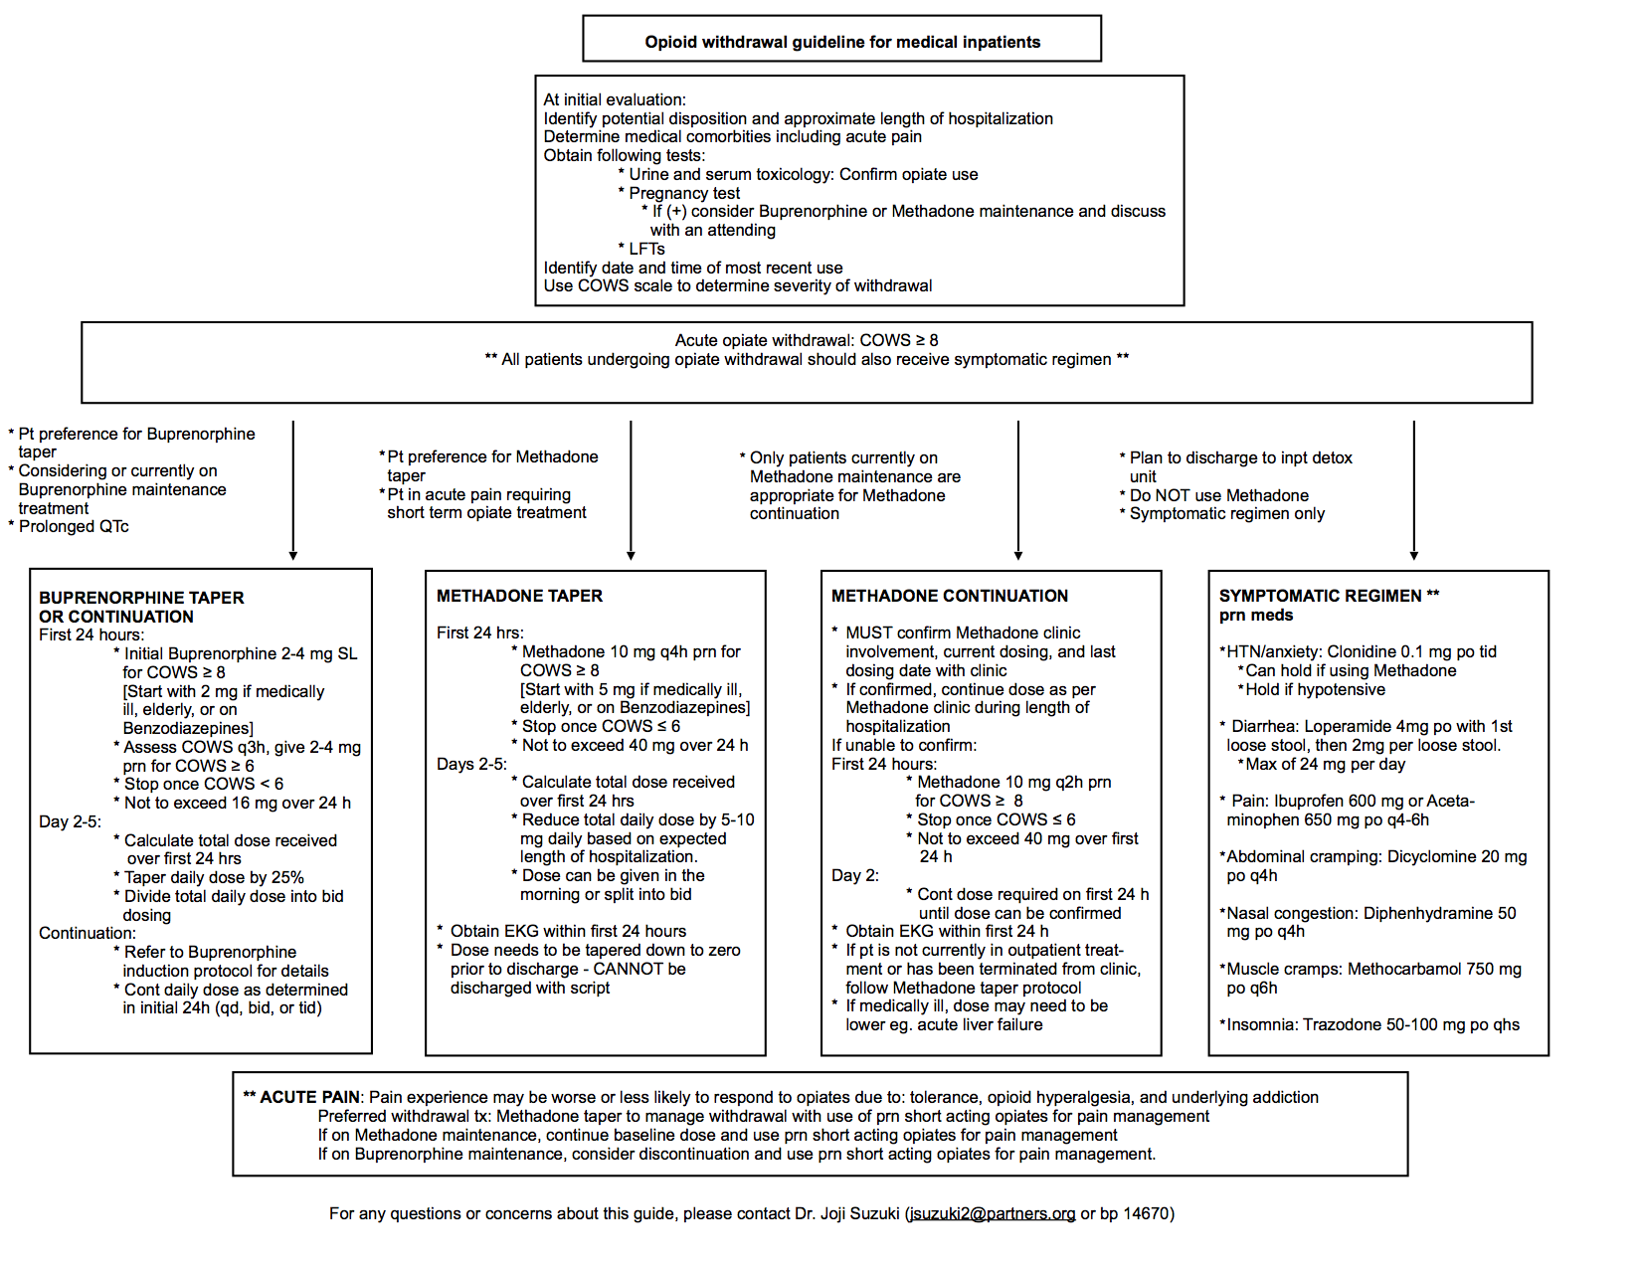
Appendix B: Decision Tree for Acute Withdrawal

Appendix C: Agitation Guidelines for Patients in Opioid Withdrawal

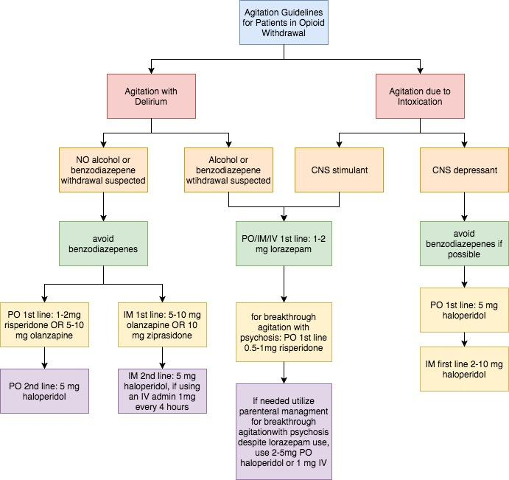

For patients over 60 years of age, reduce risperidone dose to 0.5 to 1 mg; Olanzapine doses to 0.25 mg to 0.5mg PO and 2.5mg IM; and Haloperidol 0.5mg to 1mg PO, or 1- 2 mg IM.

References

American Society of Addiction Medicine, the National Practice Guideline for the Use of Medications in the Treatment of Addiction Involving Opioid Use, 2015. http://doi.org/10.1371/journal.pone.0024459

Choi, M., Kim, H., Qian, H., & Palepu, A. (2011). Readmission Rates of Patients Discharged against Medical Advice: Cohort Study. PLoS ONE, 6(9), e24459. http://doi.org/10.1186/2046-4053-3-105

Donroe, J., Holt, S., Tetrault, J. (2016). Caring for Patients with Opioid Use Disorder in the Hospital. CMAJ, December 6, 2016, 188(17–18)
Gibson, A, Degenhardt LJ: Mortality related to pharmacotherapies for opioid dependence: a comparative analysis of coronial records. Drug Alcohol Rev 2007, 26(4):405–410. H

Hakansson, A., & Hallén, E. (2014). Predictors of Dropout from Inpatient Opioid Detoxification with Buprenorphine: A Chart Review. Journal of Addiction, 2014, 965267. http://doi.org/10.1155/2014/965267

Kerensky, T., & Walley, A. Y. (2017). Opioid overdose prevention and naloxone rescue kits: what we know and what we don’t know. Addiction Science & Clinical Practice, 12, https://ascpjournal.biomedcentral.com/articles/10.1186/s13722-016-0068-3

Mattick RP, Breen C, Kimber J, Davoli M. Buprenorphine maintenance versus placebo or methadone maintenance for opioid dependence. Cochrane Database of Systematic Reviews 2014, Issue 2. Art. No.: CD002207. http://cochranelibrary-wiley.com/doi/10.1002/14651858.CD002207.pub4/abstract;jsessionid=0C3FD9E42CBC166E8F6615DFEC526B06.f02t02

McNeil R, Small W, Wood E, et al. Hospitals as a ‘risk environment’: an ethno-epidemiological study of voluntary and involuntary discharge from hospital against medical advice among people who inject drugs. Soc Sci Med 2014;105:59-66.

Merrall EL, Kariminia A, Binswanger IA, Hobbs MS, Farrell M, Marsden J, Hutchinson SJ, Bird SM. Meta-analysis of drug-related deaths soon after release from prison. Addiction. 2010;105(9):1545–1554. https://onlinelibrary.wiley.com/doi/10.1111/j.1360-0443.2010.02990.x/full%20

Noska A, Mohan A, Wakeman S, Rich J, Boutwell A. Managing Opioid Use Disorder During and After Acute Hospitalization: A Case-Based Review Clarifying Methadone Regulation for Acute Care Settings. Journal of addictive behaviors, therapy & rehabilitation. 2015;4(2):1000138. doi:10.4172/2324-9005.1000138.

O'Connell NE, Wand BM, McAuley J, Marston L, Moseley GL. Interventions for treating pain and disability in adults with complex regional pain syndrome- an overview of systematic reviews. Cochrane Database of Systematic Reviews 2013, Issue 4. Art. No.: CD009416. http://cochranelibrary-wiley.com/doi/10.1002/14651858.CD009416.pub2/full

Rudd RA, Seth P, David F, Scholl L. Increases in Drug and Opioid-Involved Overdose Deaths — United States, 2010–2015. MMWR Morb Mortal Wkly Rep 2016;65:1445–1452. http://dx.doi.org/10.15585/mmwr.mm655051e1

Support for Hospital Opioid Use Treatment (SHOUT) is a program that provides clinical leaders with the tools they need to start and maintain patients on buprenorphine or methadone during hospitalizations for any condition, be it medical, surgical, or obstetric. Specialists from the University of California, San Francisco (UCSF) developed several supports, including: coaching, toolkits, protocols, monographs for pharmacy and therapeutics committees, webinars, and onsite presentations. Information is available at https://www.projectshout.org/

Substance Abuse and Mental Health Services Administration (SAMHSA) https://www.samhsa.gov/programs-campaigns/medication-assisted-treatment/legislation-regulations-guidelines/special

US Drug Enforcement Administration Office of Diversion Control. Title 21 Code of Federal Regulations 1306.07: Administering or dispensing of narcotic drugs

Volkow, N.D. (May 14, 2014). America's Addiction to Opiates: Heroin and Prescription Drug Abuse. Senate Caucus on International Narcotics Control. National Institute on Drug Abuse (NIH): The Science of Drug Abuse and Addiction. https://www.drugabuse.gov/about-nida/legislative-activities/testimony-to-congress/2016/americas-addiction-to-opioids-heroin-prescription-drug-abuse

500 District Ave., Burlington, MA 01803-5085
(781) 262-6000; mhalink.org

