Navigating Across Care Settings:
Choices for Successful Transitions
(NACS)
NACS is the Commonwealth’s pilot care transitions project funded by the Administration on Aging and implemented through the ADRC of the Greater North Shore (ADRCGNS). The aim of this two-year project is to effectively promote health in general and foster successful care transitions between hospital and community in particular by: 1) strengthening communications around consumer health issues across healthcare settings, 2) fostering consumer health self-management, 3) increasing awareness among professionals about care transitions 4) reducing consumer and caregiver stress and 5) reducing hospital readmissions, preventable hospitalizations and premature nursing facility placements.

NACS builds on current ADRCGNS efforts to incorporate an emphasis on health literacy and self-determination within the evidence-based Care Transitions Intervention (CTI) model developed by Dr. Eric Coleman in order to create a higher impact care transitions capacity. In addition to the core coaching component and the “four pillars” supports it delivers, NACS consumers can connect -- in concert with their desires and needs -- with “Plus” options to further strengthen their transitions and improve overall engagement in their health self-management. The “Plus” options include: Options Counseling; My Life/My Health; A Matter of Balance; other Healthy Aging programs; At Your Side Medical Advocacy; Peer Guide Supports; and Savvy Caregiver. Going forward, opportunities to develop and implement virtual coaching capacities will be integrated into the “Plus” options.

Designed as a multi-dimensional program offering sustained opportunities for education and support beyond the “standard” 30 day coaching component, the project seeks to deliver enhanced health self-management and engagement supports to 300 consumers who are a) adults with disabilities or over age 60; and b) hospitalized with a diagnosis of COPD, CHF or diabetes in either Beverly Hospital or Addison Gilbert Hospital. Key partners within the ADRCGNS for this pilot initiative include:
- Greater Lynn Senior Services, North Shore Elder Services, Senior Care (ASAPs)
- The Independent Living Center of the North Shore and Cape Ann (ILC)
- Northeast Health Systems and The Medical Group (medical partners)
 | OUTCOMES
Consumers | Caregivers | Providers
*are less likely to be re-hospitalized within 30- and 90-day periods | *feel they have more supports for effective care-giving | *know about available Care Transitions support
*feel more in control of their health routines  *follow health regimens more effectively | *are aware of available supports and how they work | *make appropriate referrals to Care Transitions supports
*feel they have more choices about how to effectively manage their health routines | *feel they can do more effective problem-solving | *believe communications with patients has improved
*communicate more effectively with health providers  *are satisfied with their health management choices  *have identified and know how to use a wider range of supports for managing their health routines  *feel more positive about their health and well-being | *feel they can cope better with stress  *believe they can better manage the health routines of the care recipient  *believe they can better manage their own daily lives | *are more willing to participate in care transitions support programs and/or integrate care transition elements into their practices
At the state level, partners include the Executive Office of Elder Affairs (EOEA), Mass Rehab Commission (MRC), MassHealth, and the University of Massachusetts Donahue Institute (UMDI). EOEA is the lead agency.

The project focuses on three domains of inquiry in order to fully assess impact:

- Fidelity. The ADRCGNS follows the protocols and tools as prescribed by the specific programs, with special attention focused on ensuring optimal fidelity with the CTI model. Coaches are provided with protocol checklists, reporting protocol adherence at each intervention. Each coach is observed implementing various aspects of the intervention at periodic intervals. ADRCGNS includes suggested CTI process indicators as part of its data gathering tool in order to monitor adherence and immediately addresses fidelity issues should they emerge.

- Consumer Satisfaction and Outcomes. NACS is designed to produce more successful transition outcomes: fewer re-hospitalizations and premature institutionalizations; greater consumer choices, self-determination, satisfaction and enhanced life quality during and following the transition process. To determine changes in these qualitative areas, ADCRGNS has incorporated critical outcome questions within the data gathering tool that also includes the CTI-3 module, the Four Pillar Scores, the Patient Activation Measurement tool (developed by Dr. Judith Hibbard and licensed to the project for use). Key questions are administered at various junctures throughout the project. The ADRCGNS wants to know whether 1) NACS transfers skills, and if so, for how long after the intervention; 2) whether the skills are used; and 3) how using the skills affects satisfaction and life quality . Finally, we wish to know whether the CTI impact is strengthened when consumers and their caregivers have access to the other community programs NACS will offer. To better understand the impact of the project on caregivers and providers, the ADRCGNS will conduct appropriate interviews and focus groups.

- Hospital Data. To assess the impact of the NACS intervention on the critical issue of hospital re-admissions at 30- and 90-day time interval will require comparison of the intervention group to rates for a baseline group. Because this is not a research study, we are not creating a contemporary control group but will, instead, identify rates for a patient group with similar characteristics within the past two years.

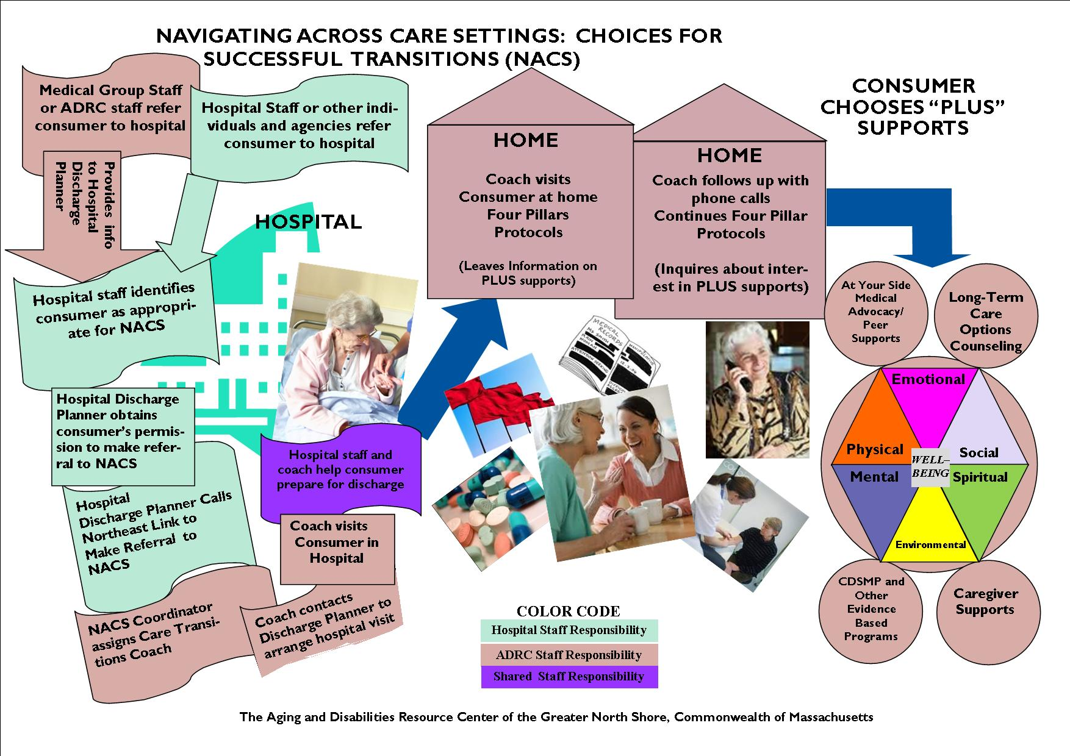

For more information on NACS, please contact: Valerie Parker Callahan, Evaluation Coordinator, vparkercallahan@glss.net ; 781-586-8612 or Cheryl Krisko, Project Director, ckrisko@nselder.org; 978-750-4540.
A 17-physician private medical practice connected with NEHS and located on the Beverly Hospital campus.
Fidelity to protocols required within the CDSMP, Options, and Caregiver programs is monitored using established tools and reporting mechanisms and is the responsibility of the respective program directors.
ADRCGNS staff brings significant experience in survey and focus group design, implementation and analysis In fact, the ADRCGNS evaluation staff has recently pioneered an image-driven focus group technique which reduces facilitator bias and diminishes the complications of constituitive meanings that often undermines this important research tool. Staff were invited to present their work on image-driven focus groups at the GSA Scientific Conference in Atlanta this past fall and the ASA/NCOA Conference in Chicago last March. This technique will be effectively integrated within our broader qualitative framework to assist in clarifying participant perceptions and decision-making.

